BABCOCK UNIVERSITY, ILISHAN – REMO, OGUN STATE
COLLEGE OF POST GRADUATE STUDIES,
SCHOOL OF NURSING
CLIENT CARE STUDY OF MRS O.C WITH PREECLAMPSIA
CLINICAL POSTING (PRACTICUM)
COURSE CODE: NRSG 831
BY
KEHINDE MOROUNRANTI ELIZABETH
MATRIC NUMBER: 15/1110
OCTOBER 2020

OUTLINE
Chapter one: Introduction
1:1 Background of the client care study
1:2 Objectives of care
1:3 Aetiology of the disease/disorder
CHAPTER TWO: LITRATURE REVIEW
2:1 Relevant Anatomy and Physiology
2:2 Pathophysiology
2:3 Clinical manifestations
2:4 Investigations (General)
2:5 Medical Surgical Nursing Management
a. Pre-operative management
b. Post-operative management
2:6 Nursing theory/model utilized
2:7 Complications and their management
2:8 Prevention and control of the case disease/disorder
CHAPTER THREE: INFORMATION ABOUT THE CLIENT
3:1 Client’s biodata
3:2 Nursing History of the client using Gordon Majory Eleven Functional Health Patterns
3:3 Physical examinations
3:4 Investigations carried out on the patient, result and their significance
3:5 Drug, Diet, Special procedures
3:6 day – to day care of the patient
3:7 Nursing care plan
3: 8 health education of patient on discharge
CHAPTER FOUR: SUMMARY AND CONCLUSION
4:1 Summary of client’s care
4:2 Conclusions
4:3 Recommendations

Chapter One: Introduction
1:1 Background to the client care study
Pre-eclampsia is a disorder of pregnancy characterized by the onset of high blood pressure and often a significant amount of protein in the urine.When it arises, the condition begins after 20 weeks of pregnancy or after giving birth (called postpartum preeclampsia). However, the symptoms and signs of preeclampsia may persist after delivery. In the majority of cases, the woman will not be aware of the signs, and will only find out when a doctor observes her during an antenatal visitation, in severe cases of the disease there may be red blood cell breakdown, a low blood platelet count, impaired liver function, kidney dysfunction, swelling, shortness of breath due to fluid in the lungs, or visual disturbancesPre-eclampsia increases the risk of poor outcomes for both the mother and the baby. An estimated 8 to 10 percent of pregnant women are diagnosed with preeclampsia — though half of those cases are among those who had high blood pressure, or hypertension prior pregnancy. it’s the cause of 15 percent (about 3 in 20) of premature births. While most cases resolve without issues .Unmanaged preeclampsia can prevent a developing fetus from getting enough blood and oxygen. If left untreated, it may result in seizures at this point it is known as eclampsia. It can also progress to HELLP, another serious syndrome that can lead to liver damage and other complications. Another concern is the higher risk of stroke during pregnancy and after delivery.
With appropriate and prompt treatment, a woman with preeclampsia near term has virtually the same excellent chance of having a positive pregnancy outcome as a woman with normal blood pressure.
This patient was selected for this study because she has a severe form of the disease, a blood pressure of 200/110mmhg on admission in a patient with normal blood pressure of 100/70mmhg. Otherwise signs of preeclampsia was also present; edema of the lower limb and presence of protein in urine. Also, the disease has negative effect on the mother and fetus, can lead to loss of the fetus, the mother or irreversible complications.
1.2 Objectives of care
To bring patient blood pressure to a normal range.
To prevent the risk of stroke in the patient during and after pregnancy
To get rid of the pedal edema
To prevent the presence of protein in urine
To prevent dangerous complications to both mother and fetus
To prevent occurrence of eclampsia
To ensure positive pregnancy outcome.

1.3 Aetiology of preeclampsia
The exact cause of preeclampsia is not certain, it involves several factors. Experts believe it begins in the placenta, the organ that nourishes the fetus throughout pregnancy. Early in pregnancy, new blood vessels develop and evolve to efficiently send blood to the placenta.
In women with preeclampsia, these blood vessels don't seem to develop or function properly. They're narrower than normal blood vessels and react differently to hormonal signaling, which limits the amount of blood that can flow through them.
Causes of this abnormal development may include:
Insufficient blood flow to the uterus
Damage to the blood vessels
A problem with the immune system
Certain genes
Risk factors
Preeclampsia develops only as a complication of pregnancy. Risk factors include:
History of preeclampsia: A personal or family history of preeclampsia significantly raises the risk of preeclampsia.
Chronic hypertension: An individual with chronic hypertension, have a higher risk of developing preeclampsia.
First pregnancy: The risk of developing preeclampsia is highest during first pregnancy.
New paternity: Each pregnancy with a new partner increases the risk of preeclampsia more than does a second or third pregnancy with the same partner.
Age: The risk of preeclampsia is higher for very young pregnant women as well as pregnant women older than 35.
Race: Black women have a higher risk of developing preeclampsia than women of other races.
Obesity: The risk of preeclampsia is higher if the person is obese.
Multiple pregnancy: Preeclampsia is more common in women who are carrying twins, triplets or other multiples.
Interval between pregnancies: Having babies less than two years or more than 10 years apart leads to a higher risk of preeclampsia.
History of certain conditions: Having certain conditions before one become pregnant, such as chronic high blood pressure, migraines, type 1 or type 2 diabetes, kidney disease, a tendency to develop blood clots, or lupus, increases the risk of preeclampsia.
In vitro fertilization: The risk of preeclampsia is increased if the baby was conceived with in vitro fertilization

Chapter Two: Literature review
2.1 Relevant Anatomy and Physiology
THE ANATOMY OF THEHEART
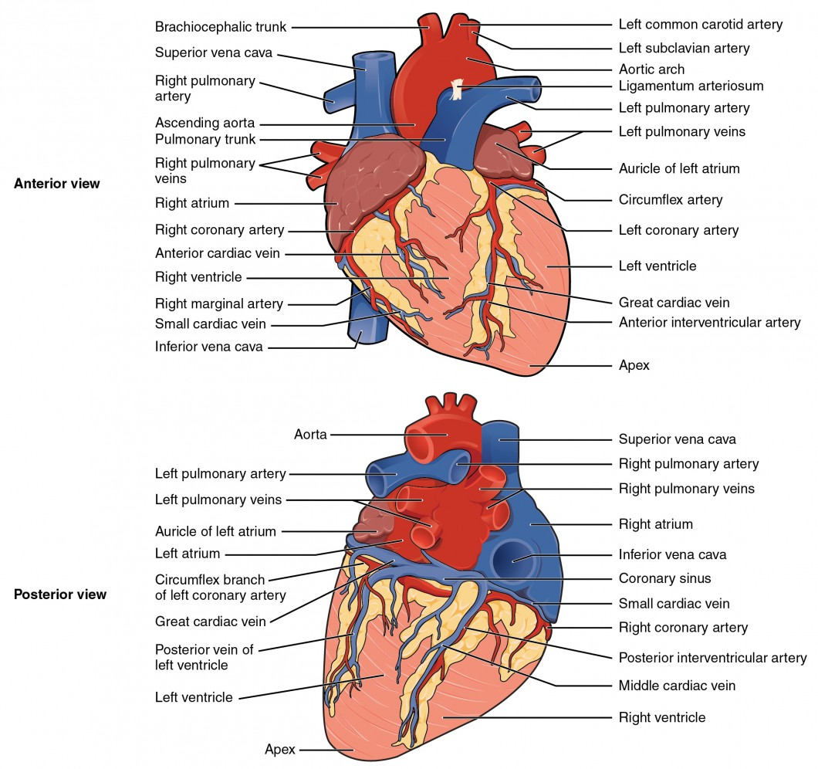

Location of the Heart
The human heart is located within the thoracic cavity, medially between the lungs in the space known as the mediastinum. Within the mediastinum, the heart is separated from the other mediastinal structures by a tough membrane known as the pericardium, or pericardial sac, and sits in its own space called the pericardial cavity. The dorsal surface of the heart lies near the bodies of the vertebrae, and its anterior surface sits deep to the sternum and costal cartilages. The great veins, the superior and inferior venae cavae, and the great arteries, the aorta and pulmonary trunk, are attached to the superior surface of the heart, called the base. The base of the heart is located at the level of the third costal cartilage. The inferior tip of the heart, the apex, lies just to the left of the sternum between the junction of the fourth and fifth ribs near their articulation with the costal cartilages. The right side of the heart is deflected anteriorly, and the left side is deflected posteriorly. It is important to remember the position and orientation of the heart when placing a stethoscope on the chest of a patient and listening for heart sounds, and also when looking at images taken from a midsagittal perspective. The slight deviation of the apex to the left is reflected in a depression in the medial surface of the inferior lobe of the left lung, called the cardiac notch.
Shape and Size of the Heart
The shape of the heart is similar to a pinecone, rather broad at the superior surface and tapering to the apex. A typical heart is approximately the size of a fist: 12 cm (5 in) in length, 8 cm (3.5 in) wide, and 6 cm (2.5 in) in thickness. Given the size difference between most members of the sexes, the weight of a female heart is approximately 250–300 grams (9 to 11 ounces), and the weight of a male heart is approximately 300–350 grams (11 to 12 ounces). The heart of a well-trained athlete, especially one specializing in aerobic sports, can be considerably larger than this. Cardiac muscle responds to exercise in a manner similar to that of skeletal muscle. That is, exercise results in the addition of protein myofilaments that increase the size of the individual cells without increasing their numbers, a concept called hypertrophy. Hearts of athletes can pump blood more effectively at lower rates than those of nonathletes. Enlarged hearts are not always a result of exercise; they can result from pathologies, such as hypertrophic cardiomyopathy. The cause of an abnormally enlarged heart muscle is unknown, but the condition is often undiagnosed and can cause sudden death in apparently otherwise healthy young people.
Chambers and Circulation through the Heart
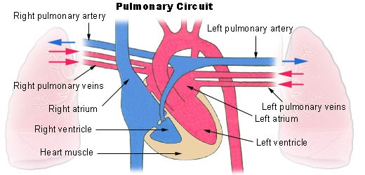

The human heart consists of four chambers: The left side and the right side each have one atrium and one ventricle. Each of the upper chambers, the right atrium and the left atrium, acts as a receiving chamber and contracts to push blood into the lower chambers, the right ventricle and the left ventricle. The ventricles serve as the primary pumping chambers of the heart, propelling blood to the lungs or to the rest of the body.
There are two distinct but linked circuits in the human circulation called the pulmonary and systemic circuits. Although both circuits transport blood and everything it carries, we can initially view the circuits from the point of view of gases. The pulmonary circuit transports blood to and from the lungs, where it picks up oxygen and delivers carbon dioxide for exhalation. The systemic circuit transports oxygenated blood to virtually all of the tissues of the body and returns relatively deoxygenated blood and carbon dioxide to the heart to be sent back to the pulmonary circulation.
The right ventricle pumps deoxygenated blood into the pulmonary trunk, which leads toward the lungs and bifurcates into the left and right pulmonary arteries. These vessels in turn branch many times before reaching the pulmonary capillaries, where gas exchange occurs: Carbon dioxide exits the blood and oxygen enters. The pulmonary trunk arteries and their branches are the only arteries in the post-natal body that carry relatively deoxygenated blood. Highly oxygenated blood returning from the pulmonary capillaries in the lungs passes through a series of vessels that join together to form the pulmonary veins—the only post-natal veins in the body that carry highly oxygenated blood. The pulmonary veins conduct blood into the left atrium, which pumps the blood into the left ventricle, which in turn pumps oxygenated blood into the aorta and on to the many branches of the systemic circuit. Eventually, these vessels will lead to the systemic capillaries, where exchange with the tissue fluid and cells of the body occurs. In this case, oxygen and nutrients exit the systemic capillaries to be used by the cells in their metabolic processes, and carbon dioxide and waste products will enter the blood.
The blood exiting the systemic capillaries is lower in oxygen concentration than when it entered. The capillaries will ultimately unite to form venules, joining to form ever-larger veins, eventually flowing into the two major systemic veins, the superior vena cava and the inferior vena cava, which return blood to the right atrium. The blood in the superior and inferior venae cavae flows into the right atrium, which pumps blood into the right ventricle. This process of blood circulation continues as long as the individual remains alive.
The blood in the pulmonary artery branches is low in oxygen but relatively high in carbon dioxide. Gas exchange occurs in the pulmonary capillaries (oxygen into the blood, carbon dioxide out), and blood high in oxygen and low in carbon dioxide is returned to the left atrium. From here, blood enters the left ventricle, which pumps it into the systemic circuit. Following exchange in the systemic capillaries (oxygen and nutrients out of the capillaries and carbon dioxide and wastes in), blood returns to the right atrium and the cycle is repeated.
Functions of the heart
The cardiovascular system is a closed system if the heart and blood vessels, it has the following functions:
The heart pumps blood through a closed system of blood vessels. Blood vessels allow blood to circulate to all parts of the body. Arteries usually colored red because oxygen rich, carry blood away from the heart to capillaries within the tissues. Veins usually colored blue because oxygen poor, carry blood to the heart from the capillaries. Capillaries are the smallest vessels within the tissues where gas exchanges take place.
It delivers oxygen and nutrients to the body tissues and removes carbon dioxide and wastes products. The vital importance of the heart is obvious. If one assumes an average rate of contraction of 75 contractions per minute, a human heart would contract approximately 108,000 times in one day, more than 39 million times in one year, and nearly 3 billion times during a 75-year lifespan. Each of the major pumping chambers of the heart ejects approximately 70 mL blood per contraction in a resting adult. This would be equal to 5.25 liters of fluid per minute and approximately 14,000 liters per day. Over one year, that would equal 10,000,000 liters or 2.6 million gallons of blood sent through roughly 60,000 miles of vessels.

The Anatomy of the Kidney
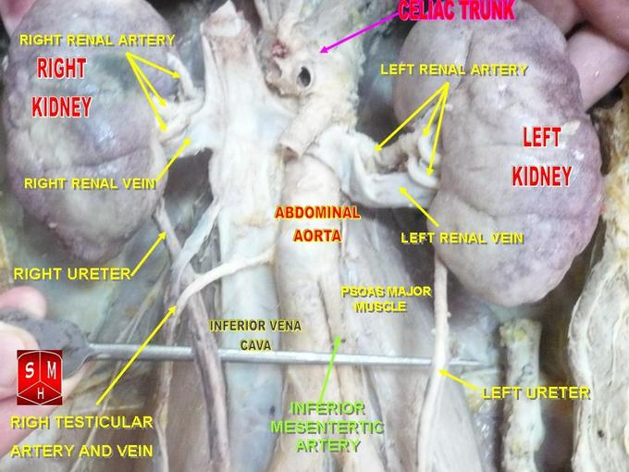
DIAGRAME SHOWING LOCATION OF THE KIDNEY
The kidneys are a pair of bean-shaped, brown organs about the size of a fist. They are covered by the renal capsule, which is a tough capsule of fibrous connective tissue. Adhering to the surface of each kidney are two layers of fat to help cushion them.
The asymmetry within the abdominal cavity caused by the liver typically results in the right kidney being slightly lower than the left, and left kidney being located slightly more medial than the right. The right kidney sits just below the diaphragm and posterior to the liver, the left below the diaphragm and posterior to the spleen.
Resting on top of each kidney is an adrenal gland (adrenal meaning on top of renal), which are involved in some renal system processes despite being a primarily endocrine organ. The upper parts of the kidneys are partially protected by lower ribs, and each whole kidney and adrenal gland are surrounded by two layers of fat (the perirenal and pararenal fat) and the renal fascia.
The kidneys are located at the rear wall of the abdominal cavity just above the waistline and are protected by the ribcage. They are considered retroperitoneal, which means that they lie behind the peritoneum, the membrane lining of the abdominal cavity.
The ureters are structures that come out of the kidneys, bringing urine downward into the bladder.

Internal Anatomy of the Kidneys

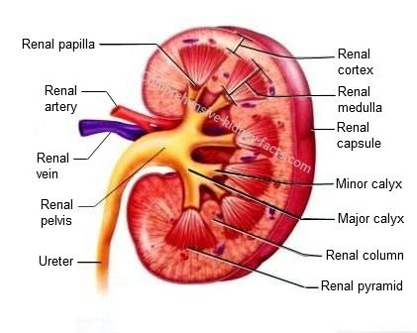
The cortex and medulla make up two of the internal layers of a kidney and are composed of individual filtering units known as nephrons.
The renal cortex, renal medulla, and renal pelvis are the three main internal regions found in a kidney.
Nephrons, masses of tiny tubules, are largely located in the medulla and receive fluid from the blood vessels in the renal cortex.
The renal cortex produces erythropotein.
The kidneys are made up by three external layers, which include the renal fascia (the outermost layer), the perirenal fat capsule, and lastly, the innermost layer, the renal capsule, which then surround the space of the renal cortex.
The Bowman’s or renal capsule, located at one end of each nephron in the cortex of the kidney, is the blood-filtering region of the nephron.
The renal pelvis contains a hilium —the concave site in which the renal artery and vein and nerves enter the kidney and the ureter leaves the kidney.
Blood supply to the kidney
The renal arteries branch off of the abdominal aorta and supply the kidneys with blood. The arterial supply of the kidneys varies from person to person, and there may be one or more renal arteries to supply each kidney.
Venous Return
The renal veins are the veins that drain the kidneys and connect them to the inferior vena cava. The renal vein drains blood from venules that arise from the interlobular capillaries inside the parenchyma of the kidney
Renal Plexus
The kidney also receives input from the parasympathetic nervous system, by way of the renal branches of the vagus nerve (cranial nerve X), which causes vasodilation and increased blood flow of the afferent arterioles. Due to this mechanism, sympathetic nervous stimulation will decrease urine production, while parasympathetic nervous stimulation will increase urine production.
The Nephron
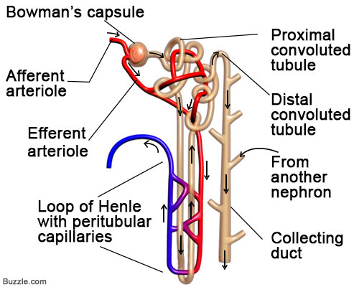
DIAGRAM OF THE NEPHRON
A nephron is the basic structural and functional unit of the kidneys that regulates water and soluble substances in the blood by filtering the blood, reabsorbing what is needed, and excreting the rest as urine. Its function is vital for homeostasis of blood volume, blood pressure, and plasma osmolality. It is regulated by the neuroendocrine system by hormones such as antidiuretic hormone, aldosterone, and parathyroid hormone.
Parts of the Nephron
Glomerulus: This is the site in the nephron where fluid and solutes are filtered out of the blood to form a glomerular filtrate. It is composed of visceral (simple squamous epithelial cells; inner) and parietal (simple squamous epithelial cells; outer) layers. The visceral layer lies just beneath the thickened glomerular basement membrane and only allows fluid and small molecules like glucose and ions like sodium to pass through into the nephron.
Proximal Convoluted Tubule: This is the first site of water reabsorption into the bloodstream, and the site where the majority of water and salt reabsorption takes place. Water reabsorption in the proximal convoluted tubule occurs due to both passive diffusion across the basolateral membrane and active transport from Na+/K+/ATPase pumps that actively transport sodium across the basolateral membrane.
Water and glucose follow sodium through the basolateral membrane via an osmotic gradient, in a process called co-transport. Approximately 2/3rds of water in the nephron and 100% of the glucose in the nephron are reabsorbed by cotransport in the proximal convoluted tubule.
Fluid leaving this tubule generally is unchanged due to the equivalent water and ion reabsorption, with an osmolarity (ion concentration) of 300 mOSm/L, which is the same osmolarity as normal plasma.
The Loop of Henle: It is a U-shaped tube that consists of a descending limb and ascending limb. It transfers fluid from the proximal to the distal tubule. The descending limb is highly permeable to water but completely impermeable to ions, causing a large amount of water to be reabsorbed, which increases fluid osmolarity to about 1200 mOSm/L. In contrast, the ascending limb of Henle’s loop is impermeable to water but highly permeable to ions, which causes a large drop in the osmolarity of fluid passing through the loop, from 1200 mOSM/L to 100 mOSm/L.
Distal Convoluted Tubule and Collecting Duct: The distal convoluted tubule and collecting duct is the final site of reabsorption in the nephron. Unlike the other components of the nephron, its permeability to water is variable depending on a hormone stimulus to enable the complex regulation of blood osmolarity, volume, pressure, and pH.
Normally, it is impermeable to water and permeable to ions, driving the osmolarity of fluid even lower. However, anti-diuretic hormone (secreted from the pituitary gland as a part of homeostasis) will act on the distal convoluted tubule to increase the permeability of the tubule to water to increase water reabsorption. This example results in increased blood volume and increased blood pressure. Many other hormones will induce other important changes in the distal convoluted tubule that fulfill the other homeostatic functions of the kidney.
The collecting duct is similar in function to the distal convoluted tubule and generally responds the same way to the same hormone stimuli. It is, however, different in terms of histology. The osmolarity of fluid through the distal tubule and collecting duct is highly variable depending on hormone stimulus. After passage through the collecting duct, the fluid is brought into the ureter, where it leaves the kidney as urine.
Functions of the Kidney
The kidneys are the primary functional organ of the renal system. They are essential in homeostatic functions such as:
Regulation of electrolytes
Maintenance of acid–base balance
Regulation of blood pressure by maintaining salt and water balances.
They serve the body as a natural filter of the blood and remove wastes that are excreted through the urine.
They are also responsible for the reabsorption of water, glucose, and amino acids, and will maintain the balance of these molecules in the body.
Produce hormones including calcitriol, erythropoietin, and the enzyme renin, which are involved in renal and hemotological physiological processes.
Production of Urine
Production of urine involves the following process:
Glomerular Filtration
Glomerular filtration occurs as blood passes into the glomerulus producing a plasma-like filtrate (minus proteins) that gets captured by the Bowman’s (glomerular) capsule and funneled into the renal tubule. This filtrate produced then becomes highly modified along its route through the nephron by the following processes, finally producing urine at the end of the collecting duct.
Tubular Reabsorption
As the filtrate travels along the length of the nephron, the cells lining the tubule selectively, and often actively, take substances from the filtrate and move them out of the tubule into the blood. The glomerulus is simply a filter and anything suspended in the plasma that can fit through the holes in the filtration membrane can end up in the filtrate. This includes very physiologically important molecules such as water, sodium, chloride, and bicarbonate (along with many others) as well as molecules that the digestive system used a lot of energy to absorb, such as glucose and amino acids. These molecules would be lost in the urine if not reclaimed by the tubule cells. These cells are so efficient that they can reclaim all of the glucose and amino acids and up to 99% of the water and important ions lost due to glomerular filtration. The filtrate that is not reabsorbed becomes urine at the base of the collecting duct.
Tubular Secretion
Tubular secretion occurs mostly in the Proximal convoluted tubule and Distal convoluted tubule where unfiltered substances are moved from the peritubular capillary into the lumen of the tubule. Secretion usually removes substances from the blood that are too large to be filtered (ex: antibiotics, toxins) or those that are in excess in the blood (ex: H+, K+). These substances secreted into the tubule are destined to leave the body as components of urine

Role of placenta in maternal-fetal circulation
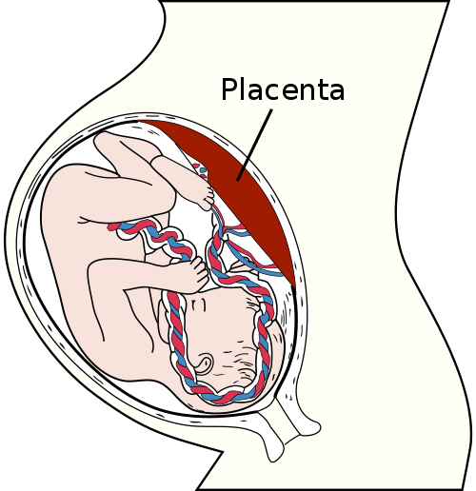
The placenta provides the primary source of sustenance to the growing fetus throughout pregnancy, delivering necessary nutrients and oxygen while removing waste. Two factors are critical in this exchange process: delivery of maternal circulation to the placenta and adequate placental surface area for an exchange of substances between the maternal and fetal circulations. The maternal circulation delivers essential substances for fetal sustenance through the spiral arteries to the placenta. Maternal blood bathes the chorionic villi that house the fetal vessels, transferring substances across the villi into the fetal veins, where they are circulated throughout the fetal system. Fetal waste is returned to the fetal arteries, housed in the chorionic villi, transferred to the maternal blood bathing the villi in the placenta, and removed by the maternal circulation through the spiral veins.
To meet the needs of the fetus as it grows, the maternal uterine spiral arteries must undergo a transformation that allows them to perfuse the placenta effectively throughout gestation. Normally, transformation of the maternal spiral arteries is established during placental development in the early weeks of pregnancy. In preeclampsia, however, this transformation is impaired, resulting in reduced placental perfusion that triggers an inflammatory response, resulting in the release of proinflammatory cytokines and creating an imbalance of proangiogenic and antiangiogenic factors.
Effect of impaired maternal fetal circulation
In the second half of pregnancy, this inflammatory process produces the classic signs and symptoms that form the basis for the preeclampsia diagnosis. The endothelial lining of blood vessels throughout the maternal circulation is damaged, causing systemic vasoconstriction and, in turn, hypertension. The damaged endothelium increases the likelihood of clot formation at the sites of endothelial damage. Products of coagulation are consumed in the formation of clots, reducing their availability in the maternal circulation and increasing the risk of bleeding. Increased vascular permeability causes fluid to move from the maternal capillaries into the interstitial space, producing edema, hemoconcentration, and reduced blood flow. Edema and vasoconstriction impair liver function, decreasing the availability of albumin and key coagulation products. Reduced renal blood flow activates the renin-angiotensin-aldosterone system, worsening vasoconstriction. Increased permeability of the renal glomerular capillaries allows protein, primarily albumin, to pass into the glomerular filtrate and be excreted in urine. Throughout the maternal system, endothelial dysfunction and reduced perfusion increase blood pressure and cause symptoms such as headache, visual disturbances, and epigastric pain.
2.2 Pathophysiology of Preeclampsia
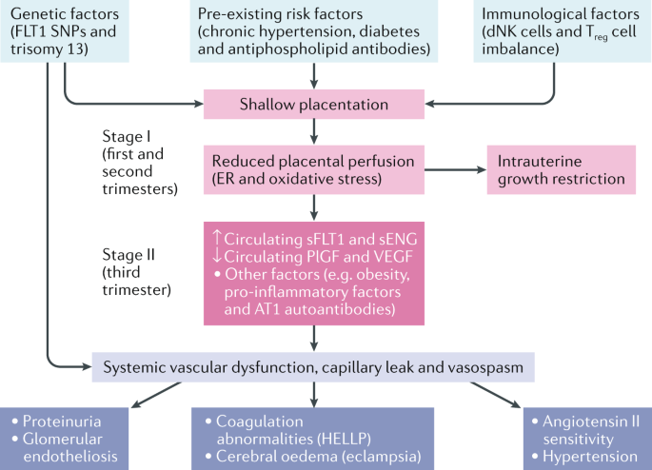
During normal pregnancy, the villous cytotrophoblast invades into the inner third of the myometrium, and spiral arteries lose their endothelium and most of their muscle fibers. These structural modifications are associated with functional alterations, such that spiral arteries become low-resistance vessels, and thus less sensitive, or even insensitive, to vasoconstrictive substances.
Pre-eclampsia has a complex pathophysiology, the primary cause being abnormal placentation. Defective invasion of the spiral arteries by cytotrophoblast cells is observed during pre-eclampsia. Recent studies have shown that cytotrophoblast invasion of the uterus is actually a unique differentiation pathway in which the fetal cells adopt certain attributes of the maternal endothelium they normally replace. In pre-eclampsia, this differentiation process goes awry. The abnormalities may be related to the nitric oxide pathway, which contributes substantially to the control of vascular tone. Moreover, inhibition of maternal synthesis of nitric oxide prevents embryo implantation. Increased uterine arterial resistance induces higher sensitivity to vasoconstriction and thus chronic placental ischemia and oxidative stress. This chronic placental ischemia causes fetal complications, including intrauterine growth retardation and intrauterine death. In parallel, oxidative stress induces release into the maternal circulation of substances such as free radicals, oxidized lipids, cytokines, and serum soluble vascular endothelial growth factor 1. These abnormalities are responsible for endothelial dysfunction with vascular hyperpermeability, thrombophilia, and hypertension, so as to compensate for the decreased flow in the uterine arteries due to peripheral vasoconstriction.
Endothelial dysfunction is responsible for the clinical signs observed in the mother, i.e., impairment of the hepatic endothelium contributing to onset of the HELLP (Hemolysis, Elevated Liver enzymes and Low Platelet count) syndrome, impairment of the cerebral endothelium inducing refractory neurological disorders, or even eclampsia. Depletion of vascular endothelial growth factor in the podocytes makes the endotheliosis more able to block the slit diaphragms in the basement membrane, adding to decreased glomerular filtration and causing proteinuria. Finally, endothelial dysfunction promotes microangiopathic hemolytic anemia, and vascular hyperpermeability associated with low serum albumin causes edema, particularly in the lower limbs or lungs.
2.3 Clinical manifestations
Sudden excessive weight gain unrelated to eating
Severe swelling of the hands and face
Swelling of the ankles (edema) that doesn’t go away
Severe headache that doesn’t respond to acetaminophen
Vision changes, including blurred or double vision
Abdominal pain, particularly in the upper abdomen
Protein in the urine
A rise in blood pressure (to 140/90 or more in a woman who has never before had high blood pressure)
Rapid heartbeat
Trouble breathing

Scant or dark urine
Exaggerated reflex reactions
Abnormal kidney function
Many of these symptoms, like weight gain and edema, can be normal in a perfectly healthy pregnancy — and high blood pressure on its own is not preeclampsia. That’s why it’s so important to monitor symptoms and, if necessary, order tests to make a definitive diagnosis.
2.4 Investigations
For a diagnosis of preeclampsia to be made, both of the following tests must come back positive:
Hypertension: High blood pressure may develop slowly, or it may have a sudden onset, the first sign of preeclampsia is commonly a rise in blood pressure. Blood pressure that exceeds 140/90 millimeters of mercury (mm Hg) or greater — documented on two occasions, at least four hours apart — is abnormal.
Proteinuria: Protein is detected in the urine. Urine samples are collected over 12 hours or more, and the amount of protein is assessed. This can indicate the severity of the condition
If preeclampsia is suspected based on the clinical features, the following tests will be required:
Blood tests: Liver function tests, kidney function tests are ordered for and also measure the platelets (the cells that help blood clot).
Urine analysis: The total urine voided in 24 hours period is collected and sent for test to see how much total protein is in the urine. A single urine sample that measures the ratio of protein to creatinine (a chemical that's always present in the urine) also may be used to make the diagnosis.
Fetal ultrasound: This is recommended for close monitoring of the baby's growth. The images of the baby created during the ultrasound exam allow for estimation of the fetal weight and the amount of fluid in the uterus (amniotic fluid).
Nonstress test or biophysical profile: A nonstress test is a simple procedure that checks how the baby's heart rate reacts when the baby moves. A biophysical profile uses an ultrasound to measure the baby's breathing, muscle tone, movement and the volume of amniotic fluid in the uterus.
2.5 Medical surgical Nursing Management
Preoperative nursing management of preeclampsia
The most effective treatment for preeclampsia is delivery. There is an increased risk of seizures, placental abruption, stroke and possibly severe bleeding until the blood pressure decreases. Of course, if it's too early in pregnancy, delivery may not be the best thing for the baby.
Admission: Severe preeclampsia may require that patient be hospitalized. Regular nonstress tests or biophysical profiles are done to monitor baby's well-being and measure the volume of amniotic fluid. A lack of amniotic fluid is a sign of poor blood supply to the baby.
History taking: Current screening approaches include preeclampsia risk identification through the collection of demographic information and comprehensive personal and family history. A personal or family history of preeclampsia may provide an opportunity to discuss potential screening and diagnostic strategies. Risks related to a short time interval between exposure to paternal semen and pregnancy can be assessed through a review of sexual history that includes duration of the sexual relationship and use of a barrier birth control method.
Monitoring of Blood pressure: Accurate blood pressure measurement is crucial, it is measured each time on the same arm with patient sitting comfortably.
Weight monitoring: Changes in body weight may indicate fluid imbalance associated with generalized edema. A weight gain of more than three to five pounds in one week, reduced urine output, or the presence of edema, including pulmonary edema, suggest preeclampsia-associated fluid imbalance, especially during the second half of pregnancy.
Laboratory investigations: Blood and urine tests may provide objective evidence of preeclampsia during pregnancy and in the postpartum period. serial nonstress testing to evaluate fetal oxygenation, ultrasound measurement of amniotic fluid volume as a proxy for fetal-placental perfusion, and estimation of fetal growth and gestational age, .Umbilical artery Doppler velocimetry, which measures blood flow in the umbilical cord or between the uterus and the placenta, may be indicated as a follow-up if there are concerns related to reduced placental perfusion.
Use of medication:
Antihypertensive: These are medications to lower blood pressure if it's dangerously high. Blood pressure in the 140/90 millimeters of mercury (mm Hg) range generally isn't treated. There are many different types of antihypertensive medications; a number of them aren't safe to use during pregnancy eg Aldomet, Nifedipine.
Corticosteroids: If the patient have severe preeclampsia or HELLP syndrome, corticosteroid medications can temporarily improve liver and platelet function to help prolong the pregnancy. Corticosteroids can also help the baby’s lungs become more mature in as little as 48 hours; this is an important step in preparing a premature baby for life outside the womb.
Anticonvulsant medications: If preeclampsia is severe, an anticonvulsant medication may be prescribed, such as magnesium sulfate, to prevent a first seizure.
Bed rest: Bed rest used to be routinely recommended for women with preeclampsia. But research hasn't shown a benefit from this practice, and it can increase the risk of blood clots, as well as impact the economic and social lives. For most women, bed rest is no longer recommended.
Delivery: If patient is diagnosed with preeclampsia near the end of pregnancy, induction of labor is recommended. The readiness of the cervix — whether it's beginning to open (dilate), thin (efface) and soften (ripen) — also may be a factor in determining whether or when labor will be induced.
In severe cases, it may not be possible to consider the baby's gestational age or the readiness of the cervix. If it's not possible to wait, the doctor may induce labor or schedule a C-section right away. During delivery, patient may be given magnesium sulfate intravenously to prevent seizures.
After delivery, it can take some time before high blood pressure and other preeclampsia symptoms resolve.
Postoperative Management of preeclampsia
Transfer patient to postpartum ward when fully conscious and stable
Monitor vital Signs every 15 minutes minutes for 1 hour, then 4 hourly
Nothing by mouth for 8 hours after cesarean section
Administer intravenous infusion 5% Dextrose saline 500mls 44hourly for 48 hours
Monitor intakes and outputs every 4 hours for 24 hours
Administer prescribed post-operative analgesic and antibiotics eg Pentazocin and Ceftriaxone
Encourage early ambulation to aid circulation and prevent complications.
Incentive Spirometry every 1 hour while awake to aid lung expansion
Commence Sips of water after 8 hour of surgery followed by liquid, soft and solid diets as tolerate.
Monitor intake and output, have Foley Catheter in place, empty urine bag and document appropriately.
Administer other Medications: Iron Sulfate dosing based on Postpartum Anemia, Prenatal Vitamin, Colace 100 mg PO bid OR 200 at bedtime, Milk of Magnesia.
Abdominal examination: Measure fundal height to monitor rate of involution.
Assess abdominal and perineal: Check the Incision site whether clean and dry. Carry out wound dressing of the site. Also assess the Lochia.
Administer Rubella shot id mother not immune: RubellaVaccine 0.5 cc SQ at Discharge
Remove Staple at 3 - 4 days post-operative
Patient is discharged after been accessed to be fit. Follow-up in clinic, Status post Cesarean Section at 2 weeks. Postpartum visit at 6 weeks.
2.6 Nursing Theory / Model utilized
NEUMAN'S SYSTEMS MODEL
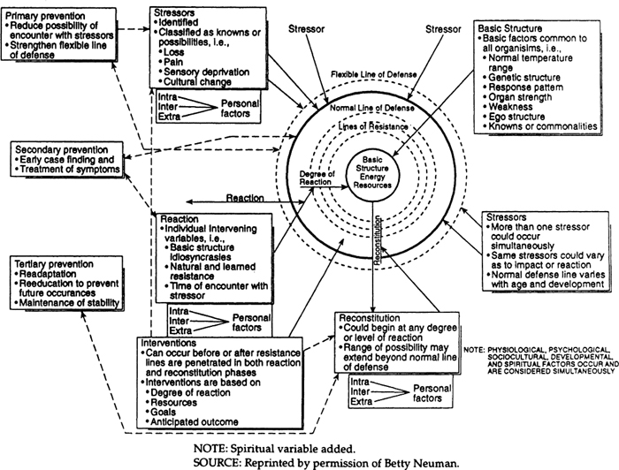
Betty Neuman (1924 – present) is a nursing theorist who developed the Neuman Systems Model. She gave many years perfecting a systems model that views at patients holistically. She inquired theories from several theorists and philosophers and applied her knowledge in clinical and teaching expertise to come up with the Neuman Systems Model that has been accepted, adopted, and applied as a core for nursing curriculum in many areas around the world.
Betty Neuman’s Systems Model provides a comprehensive holistic and system-based approach to nursing that contains an element of flexibility. The theory focuses on the response of the patient system to actual or potential environmental stressors and the use of primary, secondary, and tertiary nursing prevention intervention for retention, attainment, and maintenance of patient system wellness.
The basic assumptions of the model are:
Each patient system is a unique composite of factors and characteristics within a range of responses contained in a basic structure.
Many known, unknown, and universal stressors exist. Each differs in their potential for upsetting a client’s usual stability level.
Each patient has evolved a normal range of responses to the environment referred to as the normal line of defense. It can be used as a standard by which to measure health deviation.
The particular inter-relationships of patient variables can, at any point in time, affect the degree to which a client is protected by the flexible line of defense against possible reaction to stressors.
When the flexible line of defense is incapable of protecting the patient against an environmental stressor, that stressor breaks through the line of defense.
The client is a dynamic composite of the inter-relationships of the variables, whether in a state of illness or wellness. Wellness is on a continuum of available energy to support the system in a state of stability.
Primary prevention is applied in patient assessment and intervention, in identification and reduction of possible or actual risk factors.
Secondary prevention relates to symptomatology following a reaction to stressors, appropriate ranking of intervention priorities, and treatment to reduce their noxious effects.
Tertiary prevention relates to adjustive processes taking place as reconstitution begins, and maintenance factors move them back in a cycle toward primary prevention.
The patient is in dynamic, constant energy exchange with the environment.
In the Systems Model, prevention is the primary intervention. It focuses on keeping stressors and the stress response from having a detrimental effect on the body. Primary prevention occurs before the patient reacts to a stressor. It includes health promotion and maintaining wellness. Secondary prevention occurs after the patient reacts to a stressor and is provided in terms of the existing system. It focuses on preventing damage to the central core by strengthening the internal lines of resistance and removing the stressor. Tertiary prevention occurs after the patient has been treated through secondary prevention strategies. It offers support to the patient and tries to add energy to the patient or reduce energy needed to facilitate reconstitution.
In the Neuman’s theory, a human being is a total person as a client system and the person is a layered, multidimensional being. Each layer consists of a five-person variable or subsystem which are:
Physiological: This refers to the physiochemical structure and function of the body.
Psychological: Refers to mental processes and emotions.
Socio-cultural: This means relationships, and social/cultural expectations and activities.
Spiritual: This refers to the influence of spiritual beliefs.
Developmental; this refers to those processes related to development over the lifespan.
Neuman explains environment as the totality of the internal and external forces which surround a person, and with which they interact at any given time. These forces include the intrapersonal, interpersonal, and extra-personal stressors, which can affect the person’s normal line of defense and so can affect the stability of the system. The environment has three components: the internal, which exists within the client system; the external, which exists outside the client system; and the created, which is an environment that is created and developed unconsciously by the client, and is symbolic of system wholeness.
The Systems Model of health is equated with wellness, and defined as “the condition in which all parts and subparts, or variables, are in harmony with the whole of the client.” The client system moves toward illness and death when more energy is needed than what’s available. The client system moves toward wellness when more energy is available than is needed.
The Systems Model views the role of nursing in terms of the degree of reaction to stressors, as well as the use of primary, secondary, and tertiary interventions.
In Neuman’s Systems Model nursing process, there are six steps, each with specific categories of data about the patient.
First is the assessment of the patient, which looks at: actual and potential stressors; condition and strength of basic factors and energy sources; characteristics of flexible and normal lines of defense, lines of resistance, degree of reaction and potential for reconstitution; interaction between the patient and his or her environment; life process and coping factors for optimal wellness; and the perceptual difference between the care giver and the patient.
Second, the nurse makes a diagnosis by interpreting the data collected. The data includes health-seeking behaviors, activity intolerance, ineffective coping, and ineffective thermoregulation. The third step in the nursing process is to set goals. The ultimate goal is to keep the client system stable. From the goals, a plan is created, which focuses on strengthening lines of defense and resistance. That plan is implemented using primary, secondary, and tertiary preventions. Finally, the nursing process is evaluated to determine whether or not balance was restored, and a stable state maintained.
Applications of In Neuman’s Systems Model
Mrs O.C is an individual, a unique system that composed of factors and characteristics with a range of responses. She is to response to actual and potential stressors in the environment. There are internal and external environment. She is faced with the internal environment which is the change in body system due to pregnancy.
The pregnancy creates a stressor that she has to use the primary, secondary, tertiary prevention to reduce the actual risk factor.
She is a dynamic, constant energy exchange within the environment. The presence of pregnancy has changed her normal form to a disease state (preeclampsia).
Her state of health is altered physiologically due to the effect of pregnancy that caused preeclamsia. Alteration in placenta blood flow affects perfusion which is a physiological effect on the mother.
She is disturbed because of her present state of health- which is the psychological effect by the disease.
The primary prevention is the use of drug such as low dose aspirin and magnesium sulphate to prevent occurrence of eclampsia.
Secondary prevention is the treatment rendered to prevent complications and loss of the fetus and mother. Oral Dexamethasone was given to prevent premature labor and promote fetus lung expansion. Blood pressure maintained at normal (110/80mmHg). Edema subsided, proteinuria also controlled. Emergency caesarian section was done to save the life of the baby. Adequate care was rendered to aid quick recovery.
At recovery, the tertiary prevention comes inform of health education on prevention of preeclampsia. This requires follow up care because the blood pressure should be monitored throughout peuparium and after.
2.7 Complications and their management
Complications of preeclampsia include:
Fetal growth restriction: Preeclampsia affects the arteries carrying blood to the placenta. This deprived placenta enough blood, oxygen and fewer nutrients, which can lead to slow growth known as fetal growth restriction, low birth weight or preterm birth. This can be managed by improving circulation to the placenta’
Preterm birth: In severe preeclampsia, the woman is delivered early, to save her life and that of the baby. Prematurity can lead to breathing and other problems for the baby. This can be managed by administering injection Dexamethasone to aid lung expansion and prevent premature labour.
Placental abruption: Preeclampsia increases the risk of placental abruption. Severe abruption can cause heavy bleeding, which can be life-threatening for both mother and the baby. It is managed use of magnesium sulphate to prevent seizure (fit).
HELLP syndrome: HELLP stands for hemolysis (the destruction of red blood cells), elevated liver enzymes and low platelet count syndrome. This is a more severe form of preeclampsia, and can rapidly become life-threatening for both mother and the baby. It is managed by initiating prompt measure in management of preeclampsia to prevent occurrence of HELP, such as routine investigations and treatments.
Eclampsia: When preeclampsia isn't controlled, eclampsia, which is essentially preeclampsia plus seizures, can develop. It is managed by administration of Magnesium sulphate, low dose aspirin to prevent occurrence of seizure
Other organ damage: Preeclampsia may result in damage to the kidneys, liver, lung, heart, or eyes, and may cause a stroke or other brain injury. The amount of injury to other organs depends on the severity of preeclampsia. Prompt and adequate treatment should be instituted in a case of eclampsia to prevent damage to organs.
Cardiovascular disease: Having preeclampsia may increase the risk of future heart and blood vessel (cardiovascular) disease. To minimize this risk, after delivery try to maintain your ideal weight, eat a variety of fruits and vegetables, exercise regularly, and don't smoke. Also blood pressure should be control to reduce the effects on the heart.
2.8 Prevention of preeclampsia
Preventive measures against pre-eclampsia have been heavily studied. Because the pathogenesis of pre-eclampsia is not completely understood, prevention remains a complex issue. Below are some of the currently accepted preventive measures.
Diet: Calcium supplementation of at least 1 gram per day is recommended during pregnancy as it prevents pre-eclampsia where dietary calcium intake is low, especially for those at high risk. Higher selenium level is associated with lower incidence of pre-eclampsia. Higher cadmium level is associated with higher incidence of pre-eclampsia.
Supplementation with a balanced protein and energy diet does not appear to reduce the risk of pre-eclampsia. Further, there is no evidence that changing salt intake has an effect.
Supplementation with antioxidants such as vitamin C, D and E has no effect on pre-eclampsia incidence; therefore, supplementation with vitamins C, E, and D is not recommended for reducing the risk of pre-eclampsia.
Use of Aspirin: Taking aspirin is associated with a 1 to 5% reduction in pre-eclampsia and a 1 to 5% reduction in premature births in women at high risk. The World Health Organization recommends low-dose aspirin for the prevention of pre-eclampsia in women at high risk and recommends it be started before 20 weeks of pregnancy. Benefits are less if started after 16 weeks.
Physical activity: There is insufficient evidence to recommend either exercise or strict bed rest as preventive measures of pre-eclampsia.
Smoking cessation: In low-risk pregnancies, the association between cigarette smoking and a reduced risk of pre-eclampsia has been consistent and reproducible across epidemiologic studies. High-risk pregnancies (those with pregestational diabetes, chronic hypertension, history of pre-eclampsia in a previous pregnancy, or multifetal gestation) showed no significant protective effect. The reason for this discrepancy is not definitively known; research supports speculation that the underlying pathology increases the risk of pre-eclampsia to such a degree that any measurable reduction of risk due to smoking is masked. However, the damaging effects of smoking on overall health and pregnancy outcomes outweighs the benefits in decreasing the incidence of pre-eclampsia. It is recommended that smoking be stopped prior to, during and after pregnancy.
Immune modulation: Some studies have suggested the importance of a woman's gestational immunological tolerance to her baby's father, as the baby and father share genetics. There is tentative evidence that ongoing exposure either by vaginal or oral sex to the same semen that resulted in the pregnancy decreases the risk of pre-eclampsia. As one early study described, "although pre-eclampsia is a disease of first pregnancies, the protective effect of multiparity is lost with change of partner". The study also concluded that although women with changing partners are strongly advised to use condoms to prevent sexually transmitted diseases, "a certain period of sperm exposure within a stable relation, when pregnancy is aimed for, is associated with protection against pre-eclampsia".
Several other studies have since investigated the decreased incidence of pre-eclampsia in women who had received blood transfusions from their partner, those with long preceding histories of sex without barrier contraceptives, and in women who had been regularly performing oral sex.
CHAPTER THREE
INFORMATION ABOUT CLIENT
3.1 CLIENT’S BIODATA
INITIALS MRS O.C
SEX FEMALE
AGE 33 YEARS
OCCUPATION TEACHING
ETHNICITY IGBO
RELIGION CHRISTIANITY
MARITAL STATUS MARRIED
NUMBER OF CHILDREN TWO (5 YEARS AND TWO TEARS)
SIBLINGS 5 (THREE BROTHERS, TWO SISTERS)
DATE OF ADMISSION 07/09/2020
PROVISIONAL DIAGNOSIS PRE- ECLAMPSIA
DATE OF DISCHARGE
FINAL DIAGNOSIS
OBSTETRIC AND GYNAECOLOGICAL HISTORY G₃P₂⁺⁰ (2 A)
3:2 NURSING HISTORY OF CLIENT USINGGORDON MAJORY ELEVEN FUNCTIONAL HEALTH PATTERNS
STATE OF HEALTH:
PRESENT: Patient was referred from a private hospital on account of elevated blood pressure, edema of the lower limbs, present of protein in urine and abdominal pain.
PAST: Patient is neither hypertensive nor diabetic, nil history of surgery and blood transfusion in the past. No history of kidney disorder, hepatitis, cancer, asthma, cataract, glaucoma, seizure. She had routine immunization at childhood. No history of allergies to food or drug, does not use tobacco nor ingest alcohol.
NUTRITION: Patient feed on various Nigerian meals, nil food allergies, take 2/3 of meal served. Take about two (2) liters of water per day.
ELEMINATION: She moves her bowel once in three days; stool is brown in color with normal consistency. Pass urine with no difficulty, it is clear, amber in color, nil urethral catheter in situ, patient not having urinary incontinent.
ACTIVITY/ EXERCISE: She is not very active due to the pregnancy but engage in minimal exercise when she is strong enough to do so.
SLEEP AND REST: Patient sleeps for 8 hours at night; she feels well relaxed, sleep not usually disturbed, falls asleep spontaneously. She usually has 2 hours 45 minutes sleep during the day.
COMMUNICATION /SPECIAL SENCES: She communicates fluently in English, Igbo and little of Yoruba. She is at alert and calm, oriented to person, place, time and significant others. Her memories are intact, not confused. Her pupils are of normal size and react well to light. Her reflexes are normal with strong hand grasping and push/pull movements. Visual acuity is within normal level and she does not use glasses, read clearly. Her hearing is within normal level and she has no abnormality of smell. She possesses strong power of decision making.
PERCEPTION OF ILLNESS: Patient belief is a natural occurrence and she will get over it. She is calm, not anxious, answers question appropriately. She has a positive view about self and a strong control over the present situation. She said her previous pregnancies have always been with ease.
FAMILY/SOCIAL STATUS: She was borne into a monogamous family, the 6th child of family of 6 children, has 3 brothers and 2 sisters. She is married to a transporter and has two children. She relate well with her husband, the children and people. She is a teacher; earn daily living through it and the support from the husband.
SEXUALITY/ REPRODUCTION: She is sexually active, a gravid 3 Para 2. Her last menstrual period was 01/02/2020. No history of sexually transmitted infection and has never had pap smear. No history of use of contraceptives.
COPING WITH STRESS: Patient cope with stress by discussing the situation with the husband, then pray to God.
VALUES AND BELIEFS: She is a Christian who believes in God and value people that are honest, have integrity, trustworthy and patient. She gives to the needy, pray and fast when necessary.
OTHER INFORMATION (HABIT): Patient maintains safety precaution as much as possible such as use of seat belt when driving, regular wash of hand and use of face mask in this era of covid 19, minimal exercise and maintenance of good posture when walking and sitting.
VALUABLES B ROUGHT TO HOSPITAL: She came in with her mobile phone and some amount of money same kept in her custody.
3.3 PHYSICAL EXAMINATION
GENERAL:
A young woman not in obvious respiratory distress, not pale’ afebrile, anicteric, acyanosed , not dehydrated. There is presence of bilateral pedal edema. She is conscious GCS 15/15, oriented to time place and person.
VITAL SIGNS:
Temperature – 36.7^{oc}, Pulse – 134^{b/m}, Respiration – 20^{c/m}, B/P – 200/110mmhg, FHR – 138^{b/m}.
NUTRITION:
Patient has a good appetite, eat 2/3 of meal served, feed on various Nigeria meal, no food allergy. There is weight gain proportionate with gestational age.
MENTAL HEALTH:
Patient is conscious and at alert, well oriented. She relates well and answers questions appropriately. Her memory is intact, able to perform mental task, no incoherent speech.
SKIN:
Patient is fair in complexion, no pallor, not febrile temperature 36.7^{oc}. Skin is intact, no lesion, no dryness. Nail bed is clean. There is elasticity of the skin.
HEAD:
Her hair is evenly distributed, soft and dark in color. Normal facial symmetries, complete facial bones without deformities. Head and neck have strong strength, full range of motion and reactive to sensation.
EYES:
There is no pallor of the conjunctiva and sclera, no jaundice, no discharge. The vision is normal, pupil normal and reactive. Extra ocular movement is normal.
EARS:
Ears are normally situated and symmetrical, normal external ear, patent and clean ear canal and clear tympanic membrane.
NOSE AND SINUSES:
The nose and nasal canal are centrally located, fully patent, no polyps. There is good sense of smell with no tenderness.
MOUTH AND PHARYNX:
The lips are normal in size and shape. Buccal mucosal is moist with saliva secretion. Teeth is clean, well aligned, no dental caries. Tonsils are normally situated. There is presence of gag reflex, good sense of taste and normal tongue movement.
NECK:
Normal thyroid size and position, trachea is centrally situated, no palpable lymph node, no distended jugular vein.
PERIPHERAL VASCULAR:
Pulse rate 134^{b/m,}, temperature 36.7^{oc}, there is presence of bilateral pedal edema, nil enlargement of the lymph node.
THORAX AND LUNGS:
Anterior and posterior thorax are normal with no deformities, no lesion. Chest movement is rhythmic, vesicular breath sound of the lungs are normal with normal heart sound.
HEART:
Chest movement is rhythmic, there is normal heart sound, no murmur, pulse rate 88^{b/m}.
BREAST AND AXILLAE:
The left breast is larger than the right, nipples are prominent, both breast appear normal. Nil palpable lumps and no enlargement of the axillary lymph node
ABDOMEN:
On inspection ,abdomen is enlarged, moves with respiration, presence of strae gravidarum and linear nigra. Fundal height 30cm. No palpable contraction.
INGUINAL AREA:
On inspection the inguinal region appears normal and clean, no abnormal swelling, no herniation of any organ, vulva is clean and normal, no lesion or discharge.
SPINE AND EXTREMETIES: MUSCULOSKELETAL
The upper extremities are symmetrical and normal with no deformities and no lesion. They have full range of motion with nil tenderness. There is edema of the lower extremities. Muscle strength is strong with adequate sensation.
SPINE AND EXTRIMITIES: NEUROLOGICAL
Patella reflex and reflexes are intact; her gait is balanced and coordinated. There is adequate sensation to pain, light and touch.
3.4 INVESTIGATIONS CARRIED OUT ON THE PATIENT, RESULT AND THEIR SIGNIFICANCE

DATE | INVESTIGATIONS | RESULTS | NORMAL READINGS | SIGNIFICANCE OF RESULT
07-09-2020 | FUU BLOOD COUNT
 | WBC | 7.58 | 2.50 - 10.00 10^3/Ul | Normal
 | Neutrophil | 53.0 | 45.0 - 55.0% | Normal
 | Lymphocyte | 33.0 | 25.0 – 40. o | Normal
 | Monocyte | 12.0 | 1. 0 – 6.0% | High
 | Eosinophil | 1.6 | 1.0 – 8.0% | Normal
 | Basophil | 0.4 | 0.0 – 1.0 | Normal
 | RBC | 4.98 | 3.80 – 5.80 10^6/Ul | Normal
 | HGB | 14.2 | 11.0 – 15.0 | Normal
 | HCT | 47.2 | 47.238.0 – 45.0% | High
 | PLT | 324 | 100 – 400 10^3/uL | Normal
 | SERUM ELECTROLYTE, UREA AND CRETININE.
 | Sodium | 127 | 135 – 145mmI/I | Low
 | Potassium (serum) | 4.9 | 3.30 – 5.00mmI/I | Normal
 | Bicarbonate (serum) | 15 | 18.0 – 32.0mmoI/I | Low
 | Chloride (serum) | 103 | 95.00 – 105.00 | Normal
 | Blood urea nitrogen (BUN) | 4.0 | 1.70 – 9.10 | Normal
 | Creatinine (serum) | 68.4 | 53 – 115mmoi/i | Normal
 | Total protein (serum) | 63 | 67 – 82g/l | Low
 | Albumin | 23 | 32 – 55g/l | Normal
 | Bilirubin (Total) | 2.6 | 1.70 – 17.10umol/l | Normal
 | Bilirubin (conjugated) | 2.3 | 0.00 – 3.40U/L | Normal
 | ALT | 15 | 0 – 0.40 | Normal
 | AST | 21 | 0 – 37U/L | Normal
09/09/2020 | FULL BLOOD COUNT
 | WBC | 8.07 | 2.50 – 10.00 10^3/uL | Normal
 | RBC | 4.64 | 3.80 – 5.80 | Normal
 | HCT | 42.9 | 38.0 – 45.0 | Normal
 | PLT | 263 | 100 – 400 10^6/uL | Normal
 | Sodium (serum) | 120 | 135 – 145mmol/L | Normal
 | Potassium (serum) | 5.2 | 3.5 – 5.o | High
 | Bicarbonate (serum) | 18 | 18 – 32mmol/L | Normal
 | Chloride (serum) | 99 | 95 – 105mmol/L | Normal
 | Urea (BUN) (serum) | 6.0 | 1.7 – 9.1 | Normal
 | Creatinine (serum) | 70.7 | 53 – 115mmol/L | Normal
 | Total bilirubin (serum) | 3.6 | 1.7 – 17.1 | Normal
 | Direct bilirubin (serum) | 2.5 | <8.4mmol/L | Normal
 | Total protein | 58 | 67 – 82g/L | Low
 | Albumin | 21 | 32 – 55g/L | Normal
 | ALT | 17 | 0 – 40U/L | Normal
16/09/2020 | LIVER FUNCTION TEST
 | S – Bilirubin, total | 4 | 3 – 26umoL/L | Normal
 | S – Bilirubin conjugated | <2 | 2 – 7UmoI/L | Low
 | S - Alkaline phosphate | 138 | 51 – 117IU/L | High
 | S – g – Glutanyl transferase | 23 | 0 – 44 | IU/L
 | S – ALT (GPT) | 2.0 | <35 | NORMAL
 | S – AST (GOT) | 78 | 13 – 35IU/L | High
 | S – Total protein | 55 | 60 – 80g/L | Normal
 | S – Albumin | 20 | 35 – 50g/l | Low

07/09/2020
GENOTYPE: AA
BLOOD GROUP: O Rhesus D Positive
HIV: Negative
HBV: Negative
HCV: Negative
OBSTETRIC SCAN
FINDINGS: A viable singleton at 31 Weeks, 1 day gestation. No sonographic abnormality noted in the abdomen.
3.5 DRUGS, DIET, SPECIAL PROCEDURE
DRUGS | ACTION | NURSING IMPLICATIONS | ADVERSE EFFECTS
Aldomet | Aldomet is an antihypertensive drug. It works by relaxing blood vessel so blood can flow more easily. It help to prevent stroke, heart attack and kidney problems. | Use with caution in patient with history of previous liver disease or dysfunction.  Should not be used if there is signs of heart failure. | Dizziness, Lightheadedness, Drowsiness, Headache, weight gain, stuffy nose and weakness
Nifedipine | It belongs to a group called calcium channel blocker. It works by relaxing the muscle of the heart and blood vessel | Should be discontinued if ischemic pain occurs or worsen immediately after treatment, poor cardiac reserve, Heart failure, hepatic impairment. | Dizziness  Peripheral edema  Flushing  Tremur  Dyspnea  Hypotension  Palpitation
Ceftriaxone | It is an antibiotics, it inhibits the mucopeptile synthesis in the bacteria cell wall thereby preventing group of bacteria. | Ensure adequate hydration.  Monitor prothrombin level.  Discontinue if signs and symptoms of urolithiasis, oliguria, renal or gall bladder are seen on sonographic. | Chest pain  Weakness  Headache  Decreased urination  Seizure  Shortness of breath when exercise
Metronidazole | It is an antibiotics that prevent protein synthesis within the bacteria cell wall | Patient should avoid intake of alcohol beverage or preparation containing alcohol during and 3 days after treatment with flagyl.  Discontinue therapy immediately if symptom of CNS toxicity develop. | Nausea  Vomiting  Headache  Diarrhea  Dark urine  Dry mouth  Seizure
Paracetamol | It is an analgesic, inhibit prostaglandins synthesis thereby preventing pain sensation | Avoid overdose and chronic use as it can cause liver damage.  Monitor for signs of hepatoxicity | Liver damage  Skin reaction  Asthma  Drowsiness  Fatigue
Folic Acid | It is an hematinic used for the treatment of folate deficiency, megaloblastic anemia and prevention of neural tube defect in pregnancy. | Inform patient that urine may turn bright yellow.  Co-administration with oral contraceptives and alcohol may cause increase folic acid demand. | Stomach upset  Urine discoloration  Nausea  Vomiting  Constipation  Diziness
Vitamin C | It is an antioxidant that strengthen body natural defense. I t boost the immune system thereby protecting cells from harmful molecules called free radicals. | Take large dose of vitamin c in divided amount because the body uses only what is needed at a particular time and excrete the rest in urine.  Mega doses can interfere with absorption of vitamin B₁₂ | Diarrhea  Nausea  Insomnia  Abdominal cramp  Heartburn  Vomiting
Pentazocin | It is an opiod analgesic drug used in the treatment of moderate to severe pain and also as a pre-anesthetic agent. | Use with caution in patient with hepatic disorder  Observe for side effect  Do not administer in patient with hypersensitivity reaction | Sedation, Visual disturbance, Hallucination, Drowsiness, Syncope
Dexamethasone | It is a corticosteroid. It decreases bogy’s natural defensive response and reduces symptoms such as swelling and allergic type reactions. | Do not administer for a long period of time  Observe for a sign of hyperglycemia  Avoid giving immunization while on dexamethasone  Do not administer to patient with  Hypersensitivity reaction | Stomach upset, Headache, Menstrual changes, Weight gain, Cushing’s syndrome

3.6 DAY TO DAY CARE OF CLIENT
DATE | ACTIVITIES |  | SIGNATURE
07/09/2020  5:20pm  6:30pm |  | A 33 year old G₃P₂⁺⁰⁽2 Alive) at 31week + 1 day gestation was admitted into the ward with history of persistent high blood pressure and pedal edema of one week duration, a diagnosis of pre-eclamsia was made. On admission patient is conscious, anicteric, not in respiratory distress, well oriented to time place and person. There is swollen of the lower limp and expression of fair. Routine admission procedure done, vital signs done and recorded; temperature: 36.7, pulse: 134b/m, Respiration: 20c/m, Blood pressure: 200/110mmhg, FHR: 138b/m, urinalysis +++. Lab investigations; FBC, URINALYSIS, LIVER FUNCTION TEST were ordered for, result were within normal range except the protein sodium  , bicarbonate and protein that were low. Treatment written by Dr G.I, they are: Oral Aldomet 500mg 8hourly, Oral Nifedipine 20mg daily Oral Paracetamol 1g tds and intramuscular Dexamethasone 12mg 12hourly x 24 hours. Patient reassured and made comfortable.  Patients commenced her medications, which are oral Nifedipine 20mg, oral aldomet 500mg, oral Paracetamol 1g, and intramuscular Dexamethasone 12mg 12hourly x 24 hours.  Record of intake and output:  Total intake: 1800mls  Total output: 800mls | Aigbo
08/09/2020  8; 00am  9:00am  10:00am  11:00am  12:pm  1:30pm  2:00pm  4:00pm |  | Patient was fair met lying in bed with bilateral pedal edema. Bed making done environment tidy. Blood pressure; 160/100mmhg, Urinalysis: protein +++, FHR: 140b/m.  She ate the meal that was served, fruit also served.  Her drugs were administered;  Oral Nifedipine 20mg  Oral Paracetamol 1g  Patient had a worried facial expression. During interaction with her, she void out her concerns regarding her perceived effect of her present health status on the index pregnancy. She was reassured and encouraged to have a positive outlook towards her condition.  Foots elevated on the pillow. FHR: 132b/m, Blood pressure; 152/100mmhg, Urinalysis done, protein +++.  Meal served, patient eat 2/3 of meal served  Medication served:  Oral Aldomet 500mg  Oral Paracetamol 1g given  FHR: 140b/m  Patient advised to ambulate, she was able to walk round and had little exercise done. | Aliyu
09/09/2020  8:00am  9:00am  10:00am  11:00am  12:00pm  12: 30am  1:30pm  2:00pm  4:00PM |  | Patient met calm in bed still expressing little worry, she was told to have a positive thought towards herself and the fetus. She was health educated on the need for her to calm down and relax which will help in her quick recovery. Bed making done, her environment tidy.  Vital signs done; Temperature: 36.5^{oc}, pulse: 130b/m, Respiration: 24c/m, BP: 130/90mmhg, FHR: 140b/m.  Her medication were served:  Oral Nifedipine 500mg daily  Oral Paracetamol 1g tds  Blood sample collected for investigation by her Doctor; FBC, Urinalysis.  Patient vomited x2 containing little undigested food, she was cleaned up and made comfortable. Patient advised to avoid solid food for now, only fluid diet should be taken. Review by Doctor A. intramuscular promethazine 25mg prescribed same administered. Oral Lonart DS added to her treatment.  She was served her meal, ate 2/3 of the meal served.  Patient served her drugs:  Oral Aldomet 500mg  Oral Paracetamol 1g  ORAL Lonart DS1  Vital signs done; Temperature 37oc, Pulse:110b/m, BP: 130/80mmhg, FHR: 138b/m. | Victor
10/09/2020  8:00am  9:am  10:00am  12:00pm  2:00pm  4:00pm |  | Patient was looking bright, sitting on the chair. She verbalized a relief in her tension ability to cope, with hope that she will be well including her baby. Bed making done her corner was well arranged including her locker.  Vital signs done ; temperature:36.4, pulse 128b/respiration: 22c/m, B/P:110/7ommhg, Urinalysis done: protein+++  She was served her medication:  Oral Nifedipine 20mg daily  Oral Paracetamol 1g tds  Oral Lonart DS 1  Result of laboratory investigation reviewed, the albumin level still low, patient encouraged to take 6 eggs in a day. She was not happy about it initially, she was made to understand the importance and that aids compliance.  Lunch was served same well tolerated.  Vital sings done: Temperature: 36.2^{0c} , Pulse:116b/m, Respiration:20c/m, Blood pressure:110/80mmhg , FHR: 138b/m  Patient had adequate rest. | Mustapha
11/09/2020  8:00am  9:00am  9:30am  10:00am  2:OOpm  4:00pm |  | Mrs O.C. was looking bright with a smile on her face. She said she slept well and feels better. She moved her bowel and empty her bladder. Urinalysis done protein +++.  During an interaction section with her, she disclosed that she was not just mindful of her health, the blood pressure has been increasing gradually, her mother always complains whenever she told her about change in her blood pressure. Patient said since it was not affecting her in anyway, she refuse take it serious. She was educated on prompt intervention to any deviation from normal in health  Vital signs done Blood pressure: 117/75mmhg  Medication served:  Oral Nifedipine 20mg daily  Oral Lonart DS 1  Lunch served same tolerated.  Oral Aldomet 500mg  Adequate rest ensured | OLatunde
14/09/2020  8:00am  9:00am  10:00am  11:00am  1:00pm  4:00pm |  | Patient was met having a worried look having abdominal pain which started about 4 hours ago. She was reassured and nurse in left lateral position. Bed making done environment tidy.  Vital signs done temperature: 37.1^{oc}, pulse: 132b/m, respiration: 42c/m, Blood pressure: 140/90mmhg, FHR: 138b/m.  Patients medication served:  Oral Nifedipine 20mg daily  Oral Paracetamol 1g t.d.s  She was reviewed by Doctor Olarewaju, patient booked for an emergency caesarian section. Procedure explained to her and the husband, consent form signed. Pubic hair shaved.  Patient transferred to the theatre for caesarian section.  She was said to have had a live male neonate extracted by Doctor Olarewaju at 2:00pm. Apgar score 8:10 at one minute and 10:10 at 5 minute. Birth weight 1.15kg, estimated blood loss 400mls.  BABY  Airway was cleared, complete examination of the new born was conducted, and nil external abnormality was detected. Baby transferred to neonatal unit on account of prematurity. | Thomas
15/09/2020  8:00am  9:00am  9:30am  10:00am  2:00pm  4:00pm |  | Patient was met sleeping, intravenous 5% Dextrose saline 6hourly in progress at 21 drops per minute.  Vital signs done; Temperature 37oc, pulse: 92b/m, Blood pressure: 130/70mmhg.  Commenced on oral zip, same tolerated.  Oral Antihypertensive server:  Nifedipine 20mg daily  Aldomet 500mg 8hourly  Intravenous Metronidazole 500mg 8hourly given.  Intramuscular Paracetamol 600mg given  Fluid diet served.  Fluid Balance:  Total intake – 2000mls  Total output - 1200mls  Adequate rest ensured. | Victor
16/09/2020  8:00am  9:00am  10:00am  11:00am  1:30pm  2:00pm |  | She was awake, had a calm night, able to have a sound sleep. Intravenous 5% Dextrose saline 6hourly in progress at 21 drops per minute. Lochia is draining same normal in color and constituency.  Vital signs done; Temperature: 36.6oc, Pulse92b/m, Respiration: 24c/m, Blood pressure: 159/90mmhg .  Medication served:  Oral Nifedipine 20mg daily  Intravenous ceftriaxone 1g daily  Intamuscular Diclofenac 75mh 12hourly  She was reviewed by the managing term, intravenous infusion discontinued, parenteral analgesic and antibiotics converted to oral;  Cefpodoxine 200mg 12hourly  Paracetamol 1g t.d.s  Metronidazole 400mg 8hourly  Vitamin C 100mg t.d.s  Lunch served same well tolerated.  Medication served:  Oral Aldomet 500mg 8hourly  Oral Paracetamol 1g  Vitamin c 100mg t.d.s | Olatunde
17/09/2020  8:00am  9:00am  10:00am  2:00pm  4:00pm |  | Patient was met sitting on a chair expressing breast milk that will be taken for the baby. She had a calm night, now much better. Bed making done environment tidy.  Vital signs done; Temperature: 36.8oc, Pulse:86b/m, Respiration: 24c/m, Blood pressure: 130/80mmhg .  Medication served:  Oral Nifedipine 20mg  Oral Paracetamol 1g  Oral Vitamin c 100mg t.d.s  Meal served same tolerated  Adequate rest ensured. | Thomas
18/09/2020  9:00am  10:00am  2:00pm |  | Patient had a peaceful night; she was looking bright and smiling. Edema of the lower limps resolving, moved bowel and emptied her bladder in the toiler.  Vital signs done; Temperature: 36.3oc, Pulse:90b/m, Respiration: 22c/m, Blood pressure: 120/80mmhgmmhg .  Medication served:  Oral Nifedipine 20mg daily  Oral Paracetamol 1g  Oral Vitamin c 1  Patient’s meal served same tolerated.
21/09/2020  8:00am  9:00am  10:00am  2:00pm |  | She was looking very bright, preparing to go and visit baby in the neonatal unit with the expressed breast milk. Lower limp edema has greatly resolving .  Vital signs done; Temperature: 36.2oc, Pulse:80b/m, Respiration: 24c/m, Blood pressure: 120/70mmhg .  Medication served:  Oral Nifedipine 20mg  Oral Paracetamol 1g  Oral Vitamin c 100mg t.d.s  Meal served same tolerated  Medication served:  Oral Aldomet 500mg 8hourly  Oral Paracetamol 1g  Vitamin c 100mg t.d.s | Aliyu
22/09/20208:00am  10:00am  1:30pm  2:00pm  4:00pm |  | Patient has much improved, met sitting on chair. She verbalized much improvement in her health condition. Edema has resolved and blood pressure well controlled.  Medication served:  Oral Nifedipine 20mg  Oral Paracetamol 1g  Oral Vitamin c 100mg t.d.s  Lunch served same tolerated.  Medication served:  Oral Aldomet 500mg 8hourly  Oral Paracetamol 1g  Vitamin c 100mg t.d.s  Had adequate rest
23/09/2020  8:00am  9:00am  10:00am  1:30pm  2:00pm  4:00pm |  | Patient was fine, looking active. She ate the breakfast served  Vital signs done; Temperature: 36.7oc, Pulse: 82b/m, Respiration: 24c/m, Blood pressure: 110/70mmhg.  Medication served:  Oral Nifedipine 20mg  Oral Paracetamol 1g  Oral Vitamin c 100mg t.d.s  Lunch served same tolerated.  Medication served:  Oral Aldomet 500mg 8hourly  Oral Paracetamol 1g  Vitamin c 100mg t.d.s  Had adequate rest | Tunmishe
24/09/2020  8:00am  10:00am  12:oopm |  | She had a calm night, baby still in the neonatal unit. She expresses breast milk and take to the unit for feeding the baby, also producing adequately. Mother eat regularly with adequate diet.  Vital signs done; Temperature: 36.7oc, Pulse: 84b/m, Respiration: 22c/m, Blood pressure: 115/75mmhg.  Medication served:  Oral Nifedipine 20mg  Oral Paracetamol 1g  Oral Vitamin c 100mg t.d.s  Patient was reviewed by Doctor olarewaju and team who found her fit for discharge. She was discharged to come for follow up appointment in two weeks (07/10/2020). Baby still in Neonatal unit due to prematurity.  Take home drugs are:  Oral Aldomet 500mh 12hourly  Nifedipine 20mg daily  Oral Folic Acid 5mg daily  Oral vitamin c 199mg t.d.s  Oral Cefpodoxine 200mg 12  Oral Vitamin Bco 1 b.d  Heath education was given on discharge. Mrs O.C left the ward in a good condition. She got accommodation in mothers lodge which will make it easy for her to visit the baby in Neonatal ward and to supply breast milk | Aliyu

3.7. NURSING CARE PLAN OF MRS O.C. WITH PREECLAMPSIA
Pre – operative Nursing care plan of Mrs O. C
S/N | DATE/TIME | NURSING DIAGNOSIS | NURSING OBJECTIVES | NURSING IN TERVENTION | SCIENTIFIC PRINCIPLES |  | EVALUATION |  | SIGNATURE
1 | 07/09/2020  7pm | Ineffective tissue perfusion related to vasoconstriction of blood vessel evidenced by blood pressure of 180/120mmHg. | Patient’s blood pressure will come down to 120/70mmHg within 24 hours of nursing action. | - Access blood pressure  - Nurse in recumbent position  - Serve meal low in salt  - Administer prescribed antihypertensive drugs. eg Aldomet  - Monitor vital signs | - It serves as a base line data.  - It aids comfortab ility.  - It lowers the blood pressure  - It monitoes the progress of the disease. | Patient had a normal blood pressure of 120/70mmHg within 24 hours of nursing action. |  | Nurse  Bamidele
2 | 07/09/2020  7pm | Deficient fluid volume less than body require related to fluid shift out of the vascular compartment evidenced by edema formation. | Patient will be free of signs of generalized edema within 5 days of nursing action. | - Weigh patient on admission.  - Differentiate physiological and pathological edema of pregnancy.  - Serve meal rich in protein  - Monitor intake and output  - Examine urine voided for the presence of protein  - Substitute fluid either orally or parenteral | - It serves as a base line data  - To make adequate diagnosis  - To replace the loss protein  - To monitor fluid balance and function of the kidney.  - To monitor progress of the disease  - To replace fluid loss | Patient was free of signs of generalized edema within 5 days of nursing action. |  | Nurse  Aigbo
3 | 07/09/2020  8pm | Deficient knowledge related to unfamiliarity with information resources evidenced by request for information | Patient will verbalize understanding of disease process and appropriate treatment plan within 30 minutes of nursing action. | - Access patient/couple’s knowledge of the disease process.  - Provide information about pathophysiology of preeclampsia, implications for mother and fetus.  - Provide information about signs/symptoms indicating worsening of condition and instruct patient to notify healthcare provider. | - To know their level of understanding of the disease.  - To broaden patients knowledge of the disease condition.  - To prevent complications | Patient verbalized understanding of disease process and appropriate treatment plan within 30 minutes of nursing action. |  | Aliyu
4 | 14/09/2020 | Anxiety related to unknown outcome of surgery evidenced by patient asking various questions. | Patient’s anxiety will be allayed within 1 hour of nursing action | - Access patient level of anxiety  - Create nurse patient relationship  - Explain the procedure to the patient  - Show her patient that has recovered from the same type of surgery | - It serves as base line data  - It develop patients confidence in health care personnel  - It promotes understanding.  - It build patient confidence. | Patient’s anxiety Was allayed within 1 hour of nursing action |  | Nurse  Thomas

Post – operative Nursing care plan of Mrs O.C
S/N | DATE/TIME | NURSING DIAGNOSIS | NURSING OBJECTIVES | NURSING INTERVENTION | SCIENTIFIC PRINCIPLE | EVALUATION | SIGNATURE
1 | 14/09/2020 | Acute pain related to surgical incision evidenced by pain score of 8/10 | Patient pain score will reduce to 3/10 within 15 minutes of nursing action | - Access pain level  - Nurse in comfortable position  - Provide diversional therapy  - Administer prescribed analgesic e.g Pentasocin | - It serve as a base line data  - It provides comfort  - It temporarily take patient mind off the pain  - It block the part way of pain | Patient pain score reduced to 3/10 within 15 minutes of nursing action
2 | 14/09/2020  6pm | Deficient fluid volume less than body requirement related to treatment modality (Nil per oral) evidence by dry lips. | Patient will have a moist lip and show no sign of dehydration within 48 hours of nursing action | - Access level of dehydration  - Give intravenous infusion  - Regulate rate of flow  - Monitor intake and output | - It serves as a base line data  - It replace the lost fluid  - To prevent cardiac overload  - To maintain fluid balance and monitor kidney function | Patient had a moist lip and show no sign of dehydration within 48 hours of nursing action
3 | 15/09/2020  5am | Risk for surgical site infection related to surgical intervention | Patient will not show any sign of infection within 72 hours of nursing action | - Maintain aseptic technique  - Serve nourishing fluids/ diet  - Use of universal precaution  - Administer prescribed antibiotics e.g Cftriaxone | - It limit the rate of infection  - It build body immunity  - It also controls infection.  - It inhibit synthesis of protein within the bacteria cell wall |  | Nurse  Victor
4 | 15/09/2020  5am | Bathing self-care deficit related to weakness of the body evidence by inability to care for oneself | Patient hygiene will be maintained within 72 hours of nursing action. | - Access level of hygiene  - Give daily bed bath  - Give daily oral hygiene  - Change sanitary pad  - Change soiled linen | - Serves as base line data  - It refreshes the body  - It prevent dental caries  - It promote good hygiene and make patient comfortable  - It also make patient comfortable | Patient hygiene was maintained within 72 hours of nursing action. | Nurse Bamidele

Nursing care plan for Baby O.C
S/NO | DATE/TIME | NURSING DIAGNOSIS | NURSING OBJECTIVE | NURSING INTERVENTION | SCIENTIFIC PRINCIPLES | EVALUATION | SIGNAQTURE
1 | 14/09/2020  4PM | Ineffective airway clearance related to mucus secretion evidenced by drainage of mucus from the oro- nasal orifice | Baby’s airway will be free of secretion within 5 minutes of nursing action | - Nurse in comfortable position for resuscitation  - Clear airways of mucus by using mucus extractor  - Observe for response and stability  - Monitor vital signs | - It aids drainage of secretion  - It remove secretions from the airway  - To monitor progress  - As above
2 | 14/09/2020  4:30pm | Risk for hypothermia related to transition from intra-uterine life | Baby will maintain a temperature of 36ºc – 36.5ºc within 3 days of nursing action | - Check temperature level  - Avoid bathing baby immediately after delivery  - Clean up liquor and other fluids from baby’s skin  - Cover baby properly in a warm room | - Serves as base line data  - It prevents heat loss  - It also prevent heat loss  - It conserves baby’s heat | Baby maintained a temperature of 36ºc – 36.5ºc within 3 days of nursing action

3.8 HEALTH EDUCATION OF THE PATIENT ON DISCHARGE

CHAPTER FOUR
SUMMARY AND CONCLUSION
4.1 SUMMARY OF CLIENT’S CARE
This study was conducted on Mrs O.C., a 33year old G₃P₂⁺⁰ (2 Alive) at 31 weeks gestation was admitted into the antenatal ward of Lagos University Teaching Hospital, Idi – Araba Lagos on 07/09/2020.She presented with bilateral edema of the lower limp and elevated blood pressure. A medical diagnosis of Preeclampsia was made. She was managed pharmacologically (Antihypertensive). Physical and psychological care rendered, health education on diet promotion of good health was given.
On 14/09/2020, patient at 32 weeks gestation, she had abdominal pain which persist for hours, she was booked for emergency caesarian section. A live male neonate was extracted at 2:00pm. Apgar score 8:10 in 1 minute and 10:10 in 5 minutes, birth weight 1.15kg, airway cleared, kept warm. Baby was transferred to neonatal unit on account of prematurity.
Mother was transferred to postnatal ward, post-operative nursing care rendered. Patient improved greatly and was discharge on 24/09/2020 In a satisfactory condition. Baby is still in the neonatal unit.
4.2 CONCLUSION
Preeclampsia is a condition during pregnancy where there is a sudden rise in blood pressure and swelling, mostly in the face, hands, and feet.
Preeclampsia is the most common complication to occur during pregnancy. It generally develops during the third trimester and affects about 1 in 20 pregnancies.
If the preeclampsia remains untreated, it can develop to eclampsia, in which the mother can experience convulsions, coma, and can even die. However, complications from preeclampsia are extremely rare if the mother attends her prenatal appointments.
RECOMMENDATIONS
In areas where dietary calcium intake is low, calcium supplementation during pregnancy (at doses of 1.5–2.0 g elemental calcium/day) is recommended for the prevention of pre-eclampsia in all women, but especially those at high risk of developing pre-eclampsia.
Low-dose acetylsalicylic acid (aspirin, 75 mg) is recommended for the prevention of pre-eclampsia in women at high risk of developing the condition. It should be initiated before 20 weeks gestation.
Women with severe hypertension during pregnancy should receive treatment with antihypertensive drugs.
Magnesium sulfate is recommended for the prevention of eclampsia in women with severe pre-eclampsia in preference to other anticonvulsants.
For settings where it is not possible to administer the full magnesium sulfate regimen, the use of magnesium sulfate loading dose followed by immediate transfer to a higher level health-care facility is recommended for women with severe pre-eclampsia and eclampsia.
In women with severe pre-eclampsia, a viable fetus and before 34 weeks of gestation, a policy of expectant management is recommended, provided that uncontrolled maternal hypertension, increasing maternal organ dysfunction or fetal distress are absent and can be monitored.
In women with severe pre-eclampsia at term, early delivery is recommended.
In women treated with antihypertensive drugs antenatally, continued antihypertensive treatment postpartum is recommended.
Treatment with antihypertensive drugs is recommended for severe postpartum hypertension.
Smoking cessation especially in high-risk pregnancies eg pregestational diabetes, chronic hypertension, and history of pre-eclampsia.
References:
Clleen( 2019), preeclamsia copied on 20th September 2020 from www.whattoexpect.com
Alice Petiprin (2016), Preeclampsia accessed on 20th September 2020 from www.nursingtheory.org
Preeclampsia www.webmd.com 2019
Mayo clinic (2020), preeclampsia copied on 27th September 2020 from www.mayoclinic.org
Jaime Herndon (2018), preeclampsia accessed on 25th september 2020 from www.healthline.com
Stylia, Goulopoulou (2017), pathophysiology of preeclampsia www.ahajournals.org
Jennifer Uzan (2011), pathophysiology of preeclampsia preeclampsia www.ncbi.nlm.nih.gov
Anderson, Clindy (2014),Eclampsia copied on 30th September 2020 from www.nursingcenter.com
American congress of obstetricians and neonatal nurses (2018), https://www.awhonn.org
Preeclampsia foundation http://www.preeclampsia
Heddah L.M (2020), Preeclampsia copied on 30th September 2020 from www.nih.nlm.nih,gov
University of saint Mary (2020), Preeclampsia accessed on 25th of September 2020 from online.stmary.edu

